PROVINCE OF HERTFORDSHIRE
R.W. Bro. Neil Connolly PGM

Catuvellauni Lodge
No 9435
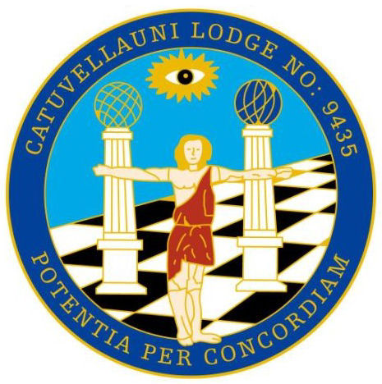
Consecrated 13th September 1991
Patron RMBI 1998 Festival + Grand Patron 2009 Festival

Master

W Bro David Curwen

Telephone: 07830 022253 | 56 Eastbourne Avenue
E-mail: sec.catuvellauni.9435@btinternet.com | Stevenage
 | Hertfordshire
 | SG1 2EX
 | Dining: 7.45pm

Friday 12th May 2023
Dear Sir and Brother
By command of The Worshipful Master, I must request your attendance at a regular meeting of the Lodge, to be held at The Cloisters, Barrington Road, Letchworth, Hertfordshire, SG6 3TH on Friday 12th May 2023 at 5.30pm promptly.

By command of the Worshipful Master

Yours fraternally
W Bro Andrew Gough ProvAGDC , PProvGStwd
Secretary

Dress: Morning or Dark Suit, White Gloves, Masonic Tie
Key Code: 4090

155th Meeting of Catuvellauni Lodge No 9435

Business:

1: Opening Ode
Produce the Warrant of The Lodge

2: To open The Lodge

3: To consider, and if approved, confirm the Minutes of the last Regular Meeting held on
Friday April 14th 2023. Previously circulated, with the summons, to all the Brethren.

4: To ratify the decisions made at the last GPC meeting by a show of hands

5: To collect Alms

6: To surrender the warrant of the Lodge

7. A brief history of the Lodge to be given by W Bro Peter Blacker

8. To close the Lodge

Brethren, YOU MUST inform the secretary of your intention: to dine, how many guests you have and dietary requirements. This is important 10 days before the meeting date.

Lodge officers 2022-2023

W Bro | David Curwen |  |  | Worshipful Master
W Bro | John Hogan |  |  | Immediate Past Master
W Bro | Peter Blacker |  |  | Senior Warden
W Bro | Andy Nicholls |  |  | Junior Warden
W Bro | Bob Quorn |  |  | Chaplain
W Bro | Ian Cargill |  |  | Treasurer
W Bro | Andrew Gough |  |  | Secretary
W Bro | George Lawrence |  |  | Director of Ceremonies
W Bro | George Lawrence |  |  | Almoner
W Bro | Ram Malocca |  |  | Charity Steward
W Bro | John Hogan |  |  | Lodge Mentor
W Bro |  |  |  | Senior Deacon
WBro | Stewart Kennedy |  |  | Junior Deacon
W Bro |  |  |  | Asst. Director of Ceremonies
W Bro |  |  |  | Asst. Secretary
W Bro | John Russell |  |  | Inner Guard
Bro | Scott Russell |  |  | Steward
Bro | Mircea Padurar |  |  | Steward
Bro |  |  |  | Steward
Bro |  |  |  | Steward
W Bro |  |  |  | Guest Organist
W Bro | Gary Woods |  |  | Tyler

PAST MASTERS of & in THE LODGE

W Bro J Sanderson | 1992 |  | W Bro R Malocca | 2019
W Bro P Blacker MBE | 2000 |  | W Bro R Malocca | 2020
W Bro J Russell | 2008 |  | W Bro J Hogan | 2021
W Bro I Cargill | 2009
W Bro A Gough | 2011
W Bro R Malocca | 2012
W Bro G Lawrence | 2015
W Bro S Kennedy | 2017 |  | W Bro R Quorn
W Bro S Kennedy | 2018 |  | W Bro A Nicholls

MEMBERS |  |  |  |  |  |  |  |  | HONORARY MEMBERS
F = Founder I = Initiate J = Joining * = Country Member
 |  |  |  |  |  |  |  |  | RW Bro Neil Connolly ProvGM
F | W Bro |  | John Sanderson | PPJGW |  |  |  |  | RW Bro Colin Harris PProvGM
F | W Bro |  | Peter Blacker MBE | PProvJGW |  |  |  |  | RW Bro Paul Gower PProvGM
F | W Bro |  | Stewart Kennedy | PPGReg LGR |  |  |  |  | VW Bro Alan Atkinson PDepProvGM
I* | Bro |  | Nick Smith |  |  |  |  |  | W Bro P Whitehead PPAGDC
I | W Bro |  | George Lawrence | PPDepGReg PProvGStwd
I | W Bro |  | John Russell | PPAsstGSuptWks
I | Bro |  | Peter Collins
I | W Bro |  | Andy Gough | ProvAGDC PProvGStwd
J | W Bro |  | Bob Quorn | PPAGReg LGR
I* | Bro |  | James Mason
J | W Bro |  | Ian Cargill | PPAGDC LGR
I | W Bro |  | Dave Curwen
I* | Bro |  | Trevor Cotter
I | Bro |  | Scott Russell
I | W Bro |  | John M Hogan
I | Bro |  | Matthew Sims
J | W Bro |  | Ram Malocca | PPAsstGSuptWks
J | W Bro |  | Andy Nicholls
I | Bro |  | Mircea Padurar
I | Bro |  | Denzil Wellman

